**GMAPS**

](https://soundcloud.com/user-879892202)

**Matrices**

**Worksheet**

**To see the additional comments and resources, make sure you select All Markup in the Review/Tracking pane**



Important note

**PART 1: HMatrix2D**

**Question 1**

Unity has a **Matrix4x4** class, but just like for vectors, we’ll create our own class called (surprise!) **HMatrix2D**.

Download the file **HMatrix2D.txt** from the **Matrices** section on LMS:

This is a template for the **HMatrix2D** class you will create.

1. Open your **GMAPS_Oct_2023_Worksheets_STUDENT** Unity project, then add a new script called **HMatrix2D.cs** inside the **Math** folder.

This is a matrix for 2D coordinate space, but because of the h value, we must declare a 3x3 array to store the matrix values.

Do that now:



1. There are THREE constructor functions in the template code.

This means we have three ways to initialise a HMatrix2D object when we instantiate one.

Remember that if we multiply a matrix A with the **identity** matrix **In**, then the result of that multiplication is just **A**, i.e. no change.

So, we would like the first constructor to initialise the matrix to the identity matrix.

But we might want to set an HMatrix2D object to identity at any time, e.g. if we have to reset it for some reason. In this case, we should create a function to do this, which we can run any time.

Complete this code:

1

2

3

4

5

6

7

8

9

10

11

12

13

14

15

16

17

Create another C# script called **TestMatrix.cs**.

Create a **new** **empty game object** in the scene called TestMatrix, add TestMatrix.cs to it, and run the project. You should see this output:

1. The code in **SetIdentity()** is rather verbose (long-winded).

It can be simplified using what is called the **ternary operator**.

Comment out (don’t delete) the original code, and replace it with the ternary operator version.

1. Now you must implement the other two constructors.

and …

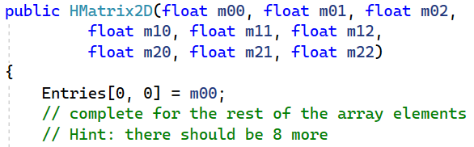

So far, you should understand what the HMatrix2D class is for, and how to create and initialise an HMatrix2D object.

This will be used to perform matrix math, rather than Unity’s built-in Matrix4x4 class.

**Question 2**

The next thing you should do is implement functions for the basic arithmetical operations for HMatrix2D: **add**, **subtract**, and **multiplication** **by a scalar** value.

1. Implement these arithmetical functions now.

Refer to your lecture slides and complete this code:

If you need a refresher on **operator overloading**, look here.

You also need to check if two HMatrix2D objects are **equal or not**.

1. Now, you must implement checking for equality.

Complete this code:

Inside the **if statement**, you need to check if any two corresponding elements are *not* equal.

If not equal, then the HMatrix3D objects aren’t equal, so return false.

If after looping across all the elements none of them cause a false return, then return true (the HMatrix2D objects are equal).



For the **!=** operator, simply reverse where the function returns true and false.

Now you have to think about the more complex multiplication of:

* matrix and vector
* matrix and matrix

In fact, the multiplication of a matrix with a vector is performed the same way as for two matrices, since a vector is really just a matrix.

But because our code defines HMatrix2D to represent a matrix, and HVector2D to represent a vector, we need a separate function for multiplying a matrix and a vector, as shown below:



Also, a matrix-by-matrix multiplication returns another matrix, but a matrix-by-vector multiplication returns a *vector*:



So, we need a * function with arguments for HMatrix2D and HVector2D objects, and another function with two HMatrix2D arguments.

This is why we must overload the * operator.

1. Implement the overloaded * operator function for **HMatrix2D * HVector2D**.

This multiplies left (a HMatrix2D object) and right (a HVector2D object), and returns a new HVector2D object.

Remember that HVector2D has three values: **x**, **y** and **h**.

So why does the function above only calculate the top *two* HVector2D values (for x and y)—what about h?

Looking at the HVector2D constructor, the answer is clear: you’ll see that it takes two arguments, **x** and **y**, and that the third value for **h** is automatically set to 1.

Remember that HVector2D is a 2D vector, with only x and y values. But it also has an extra h value. The h value is always 1, so we can just set it automatically in the constructor.

1. Implement the overloaded * operator function for **HMatrix2D * HMatrix2D**.

The first two elements in the array in the HMatrix2D template are given. You must complete the rest of the entries.

The code in the template simply hardcodes all the rows and column indexes, and then multiplies these together as shown in your lecture slides.

This is ok for small matrices, but 4x4 matrices and larger would need a more sophisticated approach.

If you search online, you might end up with more complex code that you won’t properly understand, and which isn’t *really* necessary for a small matrix.

*But* you can take a look at this link: <https://www.geeksforgeeks.org/c-program-multiply-two-matrices/>

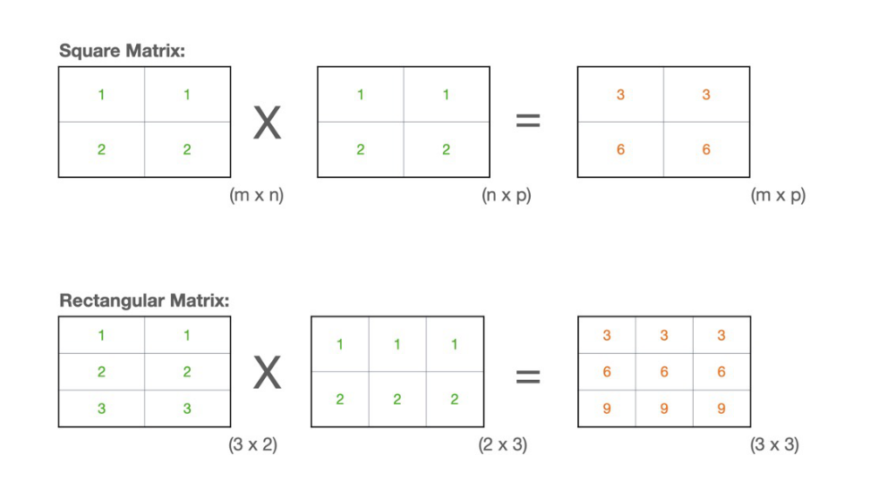

The algorithm can multiply together two square or rectangular matrices of any size.

If you’re able show that you understand the code when you submit your project (properly commenting every line, and with a high-level description of the algorithm in a comment above the function), then you can choose to use this more general approach instead.

1. In **TestMatrix**, add a function called **Question2()**.

Go to this URL:

<http://matrixmultiplication.xyz/>



Try various combinations of 3x3 * 3x3 and 3x3 * 3x1 matrices to multiply. You can step through to see the matrix multiplication in action.

Declare three HMatrix2D objects, **mat1**, **mat2**, and **resultMat**. Also declare one HVector2D object, **vec1**.

For each multiplication that you try at the website above, test that the result is the same when you run Question2() in Start().

Check that both overloaded * operator functions work in your code.

**PART 2: Application**

**Question 3**

Now you’ll implement **SetRotationMatrix** and **SetTranslationMatrix**.

1. Complete this code (refer to your lecture slides for 2D rotation matrices):

1. Complete this code (refer to your lecture slides for 2D translation matrices):

Now you have most of HMatrix2D finished!

Before applying a matrix to transform a game object, we need to access the game object’s *vertices*.

Look at **MATRICES_worksheet/Sonic/MeshManager.cs**.

This uses Unity’s **MeshFilter** component to access a game object’s **sharedMesh** vertices and store these in a Vector3 array called **vertices**.

Here’s Unity’s documentation for MeshFilter:

* <https://docs.unity3d.com/Manual/class-MeshFilter.html>

Watch these Unity videos about object meshes:

* <https://www.youtube.com/watch?v=cKJ6dQfgcAU>
* <https://www.youtube.com/watch?v=m3pblzmvFpE> (only need up to 1:30)

Read this Unity forum question:

* <https://forum.unity.com/threads/mesh-vs-shared-mesh-in-procedural-generation.583957/>

**Question 4**

1. Answer the questions below. Make sure you read the code carefully. Expand the answer text box if necessary.
2. Explain *in your own words* what MeshManager’s Awake() function does.

The MeshManager will get the **MeshFilter component** and will use that component to set the values for the originalMesh, clonedMesh, vertices and triangle using the Mesh given by the **sharedMesh** from The **MeshFilter.**

1. Explain what problem will occur if you don’t use a *cloned* mesh in this code, and how to fix it.

Look here for a hint:

<https://www.kodeco.com/3169311-runtime-mesh-manipulation-with-unity/>

It will affect the original mesh. Once changes have been done to the original mesh, it is hard to revert the changes as the changes are permanent. That is why developers shouldn’t directly change the original mesh but rather the the clone mesh.

1. Create a new script called **TransformMesh.cs** and add it to the Sonic prefab. Then drag an instance of the Sonic prefab to the scene. This should already have a **MeshManager** script attached (if not, add it).

Reset Sonic’s position to the origin.

Add these variables to TransformMesh:

What each variable represents is discussed below.

|  |  |
| --- | --- |
| vertices | These are the copies of the vertices of the sprite mesh’s vertices which are copied and stored by MeshManager. These are used to transform (translate, rotate and scale) the sprite, otherwise the sprite mesh will have the transformation permanently applied. |
| transformMatrix | This is the matrix object, which is of type HMatrix2D (this is the matrix class you defined earlier in this worksheet). You will use the SetTranslationMatrix and SetRotationMatrix methods of this class to set transformMatrix to translate or rotate the sprite. |
| meshManager | This is an instance of MeshManager, which is used to obtain a copy of the sprite’s vertices. |
| pos | This is the current position of the sprite. When rotating or scaling, the sprite must be translated to the origin, then rotated or scaled, then translated back to its original position. See the diagram below. |

Look at the diagram below. To rotate or scale a game object, we must (a) first move it to the origin, (b) perform the rotate or scale transformation, and then (c) move it back again.

The matrices declared in (b) above represent these different transformation steps.

* **toOriginMatrix**

The translation matrix for translating a vertex position in step (a).

* **toOriginMatrix**

The translation matrix for translating a vertex position in step (c).

* **rotateMatrix**

The rotation matrix for step (b).

* **transformMatrix**

The final transformation matrix, which concatenates all the matrices above (we’ll look at this later), e.g., for rotation, we perform this matrix multiplication:



This lets us perform all the separate steps as a single step! In other words, multiple transformations can be concatenated into a single *composite* transformation. This is why we use *homogeneous* coordinates.

Remember that the matrix multiplication order is right-to-left.

* **pos** is the current position of the game object stored as a HVector2D object.

**Question 5**

Next, we’ll apply the various transformations to the Sonic sprite mesh.

Complete the steps below. Make sure you read the code carefully.

1. Add the code below to **TransformMesh**:

**MeshManager** has been added as a component script to the Sonic sprite game object, so we obtain a reference to it, which is stored in **meshManager**.

Then, we store the current position of the Sonic sprite in **pos**.

If we run the scene, nothing happens! This is because we don’t have any methods for transforming the sprite.

We’ll add three methods:

* **Translate**
* **Rotate**
* **Transform**

1. Write the **Translate** method. It will look like this:

You’ll get a compilation error, because you haven’t written the **Transform** function yet.

1. Write the **Transform** method. It will look like this:

Now you have the Translate function and Transform function.

1. Modify the **Start** method so that the Sonic sprite is moved by (1, 1).

Hint: You need to call the **Translate** method. The sprite might move outside the game window, so view the transformation in the Scene view.

You have moved the sprite using a direct matrix multiplication! You didn’t use any built-in Unity API function calls, such as Transform.Translate().

Give yourself a high-five 😊

1. Now try to implement and use the **Rotate** function.

This is more tricky, and you’ll have to refer to the lecture slides.

Remember that we will use these matrices:

* **toOriginMatrix**
* **toOriginMatrix**
* **rotate Matrix**

These are multiplied together *in reverse order*, and stored in **transformMatrix**.

Some clues are given in the code below.

Now you should be able to call the Rotate method to rotate the Sonic sprite mesh:  
  
Again, you’ve used only direct matrix multiplication, with no Unity API calls. Another high-five! 😊

It’s left as an extra exercise for you to implement scaling.

**PART 3: Reflection**

**Question 6**

1. What was the most difficult part of this worksheet. Explain why you found it difficult, and how you managed to overcome this (if at all).

*You might like to reference specific lecture slides and lines of code, give some URLs and diagrams as references, etc.*

The hardest part of the worksheet is probably trying to understand what the worksheet requires me to do. I find the clues given are too vague and the function names does not really explain what I am supposed to do.

One of the questions I am referring too.

I would have to sit down there trying to figure out what is it I am supposed to do because the clues given does not help. I would feel frustrated and annoyed as I don’t know what is it that I was supposed to implement. It is only when I confront to the teacher do I know what I am supposed to do. Since the worksheet depends on one’s implementation, the code written functions like **SetRotationMatrix** can have different implementation. So having the code as guidelines just does not help since I don’t know what it is I have to implement. Other than that, the topic taught were quite easy to understand and fun to learn.

1. Choose a matrix topic that are you still unsure about. Explain that topic, and the steps you will take to clarify your doubts. You will be graded on how well you analyse your problem with understanding that topic.

If you are confident about all the topics, select what you consider to be the most difficult topic and explain ONE more advanced concept related to the topic. You will be graded on the complexity of the concept, and how well you explain it.

**Answer:**

One of the topics I find it hard to understand is **homogeneous Coordinates**. Though it was not gone through in depth, I find it interesting to learn more about it.

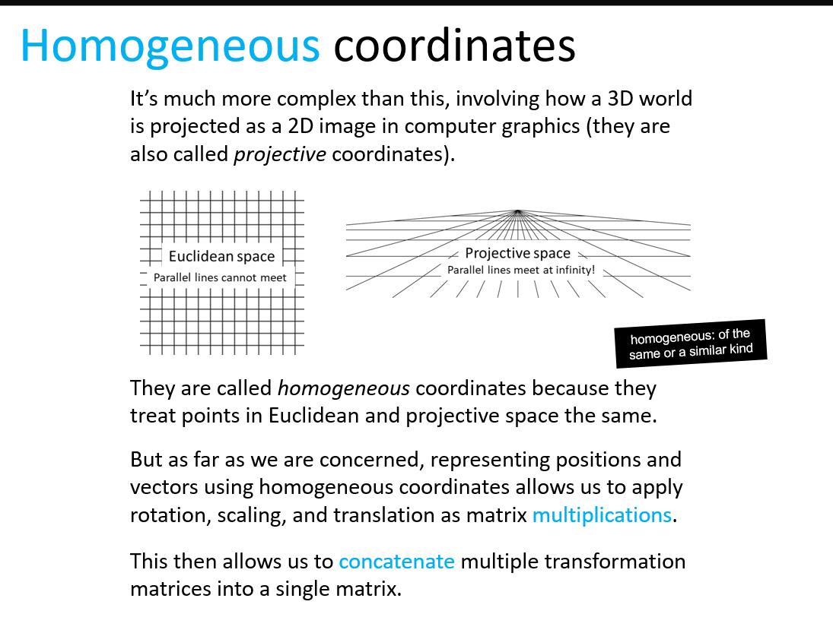

Slides from the worksheet.

I understood the concept of why it is useful for matrix multiplication, but I find that worksheet abstractexplanation of it is still quite confusing. The mathematical terms like Euclidean and projective space are still not familiar concepts in my head.

From what I know, Homogeneous coordinate adds another dimension to the matrix. If is a 2x2 matrix, it would be a 3x3 matrix. If it is a 3x3 matrix, it would be a 4x4 matrix. This is used to represent translation to matrix so that it can be applied to vectors.

However, I can’t understand what it means when “homogenous coordinates treat points in **Euclidean** and **Projective** space the same” and what is the meaning when putting 1 at the last column and row of the matrix.

With these points in mind, I try to figure out the

1. What are Euclidean and projective space?
2. What does homogenous coordinate translate objects

**After research**

After a through research, I figure out that Euclidean space is a space used to represent geometry in each space. This is usually represented with coordinates.

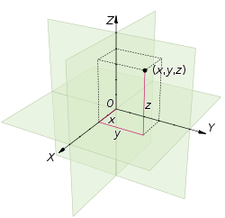

**Euclidean space and using coordinates to represent the space.**

Projective space is space where a 3D space is represented into a 2D space. This is

similar to how our eyes work when looking at far away object. Where parallel line converges at infinity.

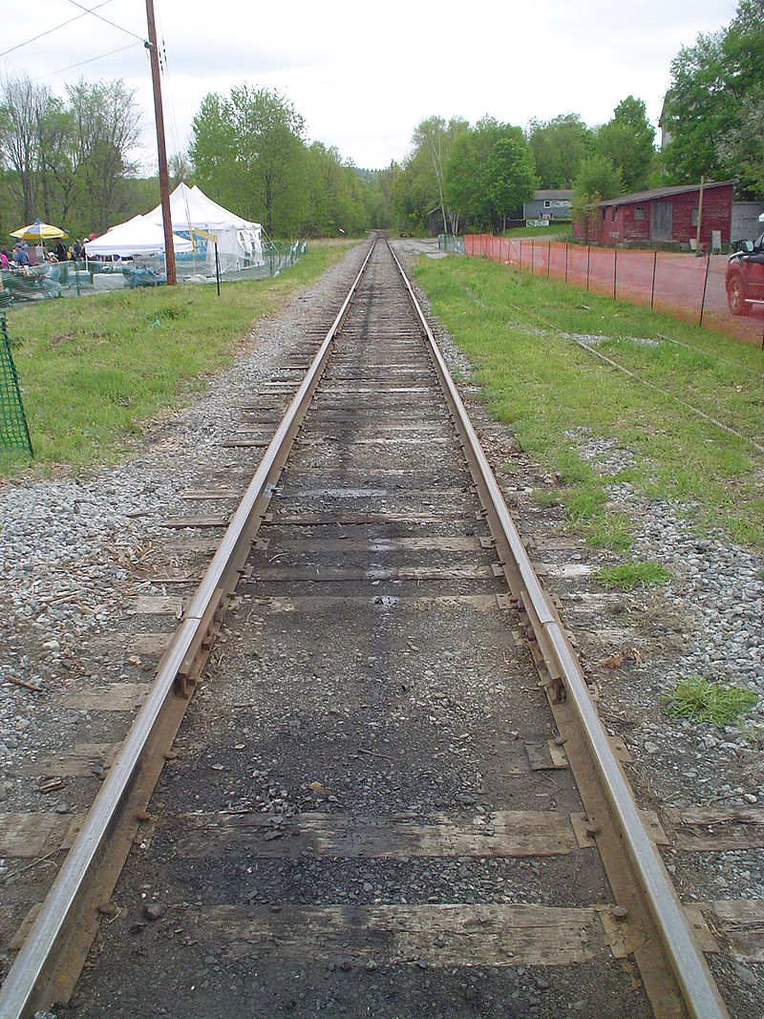

**You can see how the rail way track seem to converge in this photo because of projection.**

Homogenous coordinates are able to represent this two-space based on the **H**

value. Take the perspective space for instance, it can show 3D object into

a 2D plane because the H value give the information of the dept. That is why

the X and Y value must be divided by the H value to represent it fully in

a 2D plane.

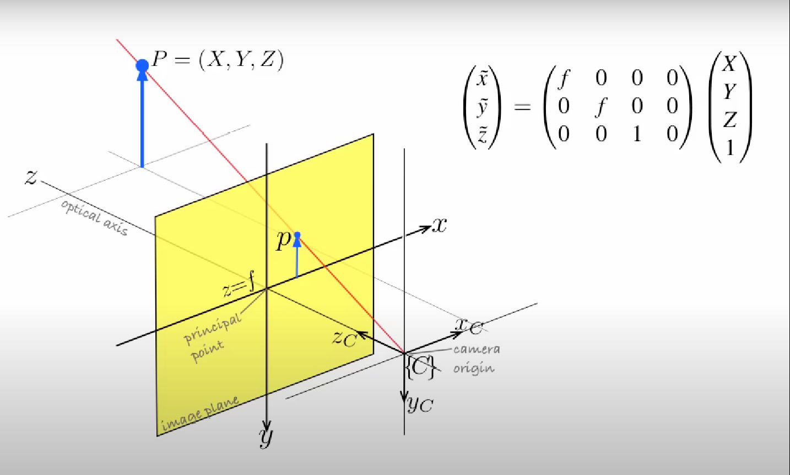

**How the H value helps to represent point in 3D to 2D.**

I also figure out why homogenous coordinate can represent translation in our 2D worksheet.

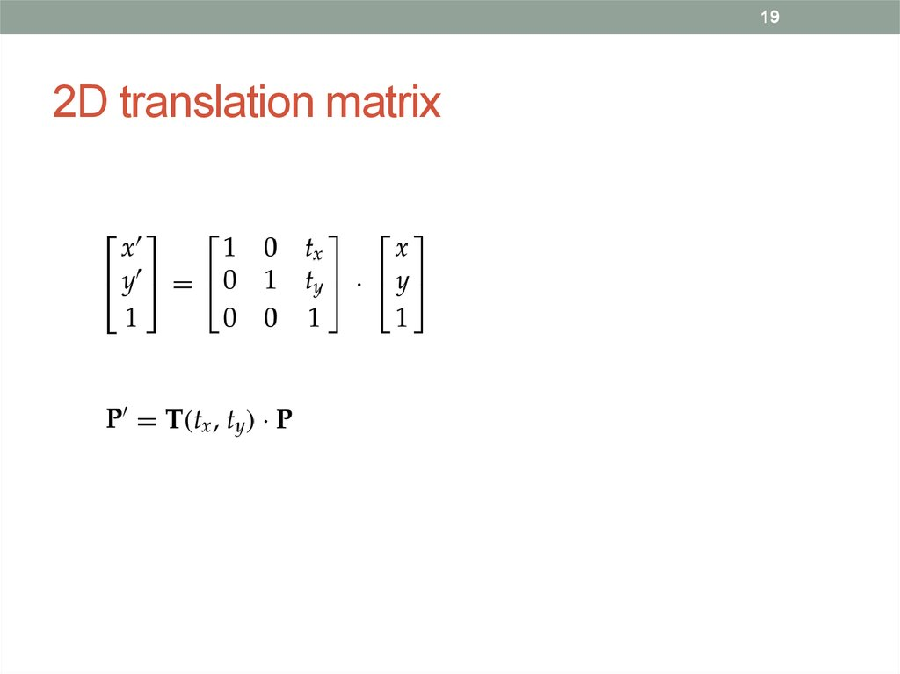

The translation matrix affects the invisible Z axis to help with the translation (shown with the Tx and Ty). Applying that transformation then help to move the point to its destination. I just found it mind blowing after realising this fact.

This gave me insight and allowed me to understand the statement.

**“Homogenous coordinates**

**are able to treat Euclidean and projection space equally”.**

This is because of the homogenous coordinate depending of the H value, it is able to represent the space as either projection or Euclidean space.

Reference: [Euclidean geometry - Wikipedia](https://en.wikipedia.org/wiki/Euclidean_geometry) , [Euclidean space - Wikipedia](https://en.wikipedia.org/wiki/Euclidean_space) , [(1) Math for Game Programmers: Understanding Homogeneous Coordinates - YouTube](https://www.youtube.com/watch?v=o1n02xKP138) , [(1) ENB339 lecture 9: Image geometry and planar homography - YouTube](https://www.youtube.com/watch?v=fVJeJMWZcq8) , [Projective space - Wikipedia](https://en.wikipedia.org/wiki/Projective_space) , [Homogeneous coordinates - Wikipedia](https://en.wikipedia.org/wiki/Homogeneous_coordinates)

1. Write a reflection about this worksheet. You may like to include how effective it is to motivate and help you learn, how well it relates to games development, etc.

This worksheet is quite fun to do. It has better help me to understand how to use matrix in its simplest applications (translating, rotating, and scaling). The worksheet and showed me how a simple concept of storing values in rectangles can allow one to do complex equations and geometry. Though the worksheet does stump me with the vague programming clues, I feel a sense of accomplishment whenever I figure out how it is being implemented. The only disappointment was not getting more questions relating to matrices and what other application can be used to be applied. With this knowledge, I am quite keen in doing my own self-directed learning to know more about the use case of matrix (I already done so before, but the worksheet does give a path to follow if I want to learn more about it). Currently, I feel like I can apply this knowledge if I want to start my own game engine or try to make my own matrix library. I am quite excited to see how matrix can be applied in games and how I might solve different problems using it.